DOKUZ EYLUL UNIVERSITY

Faculty of Engineering

Electrical and Electronics Engineering

**EED 1005 Introduction to Programming Laboratoary#4**

Student Name : Yavuz BALI Number:2014502021

**Task 1:**

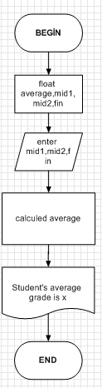

#include<stdlib.h>

#include<stdio.h>

int main()

{

float average,mid1,mid2,fin;

printf("Input first midter exam grade :"); scanf("%f",&mid1);

printf("Input second midterm exam grade:"); scanf("%f",&mid2);

printf("Input final exam grade: ");scanf("%f",&fin);

average=(mid1*20/100)+(mid2*20/100)+(fin*60/100);

printf("Student's average grade is %.1f ",average);

return 0;

}

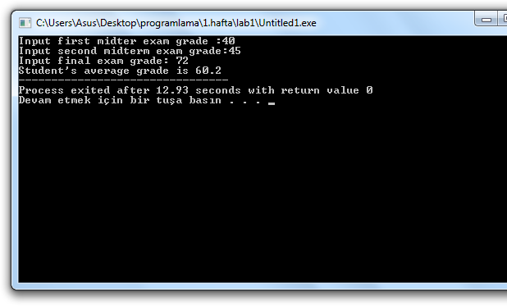

**Task 2:**

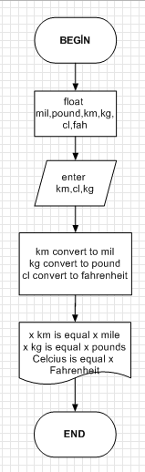

#include<stdlib.h>

#include<stdio.h>

int main()

{

float km,pound,kg,mil,cl,fah;

printf("Please enter the distance in km:"); scanf("%f",&km);

printf("Please enter the weight in kg:"); scanf("%f",&kg);

printf("Please enter the temperature in celcius:"); scanf("%f",&cl);

mil=km*0.6214;

pound=kg*2.205;

fah=(cl*9/5)+32;

printf("%.1f km is equal %.1f miles\n",km,mil);

printf("%.1f kg is equal %.1f pounds\n",kg,pound);

printf("%.f Celcius is equal %.1f Fahrenheit\n ",cl,fah);

}